**screenshot for assignment 1**

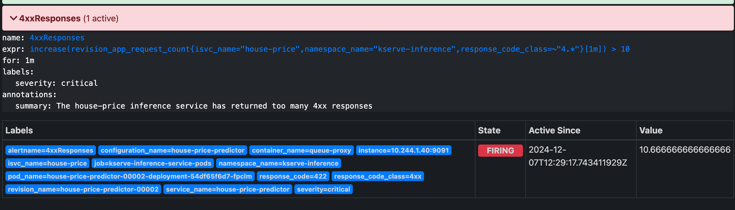

**screenshot for assignment 3**

**The dashboard showing the MAE changes in 2017**

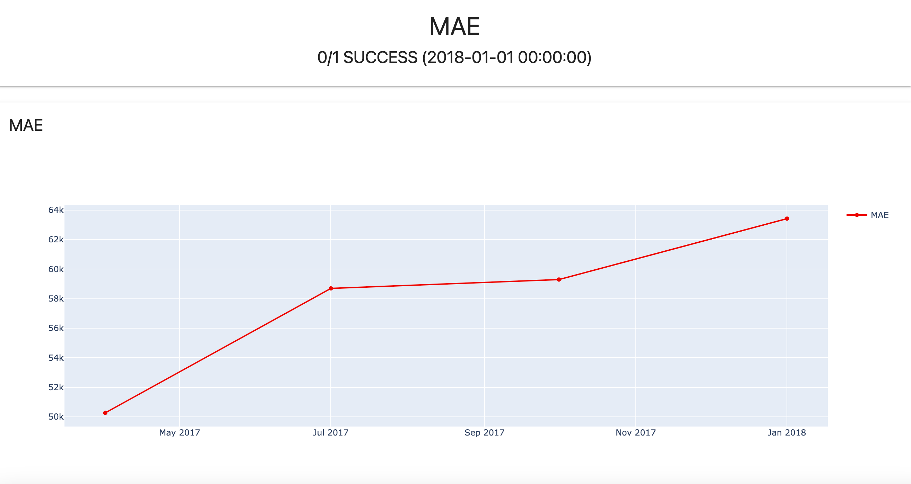

**The Evidently Report for quarter 3 of 2017**

1)"Regression Model Performance

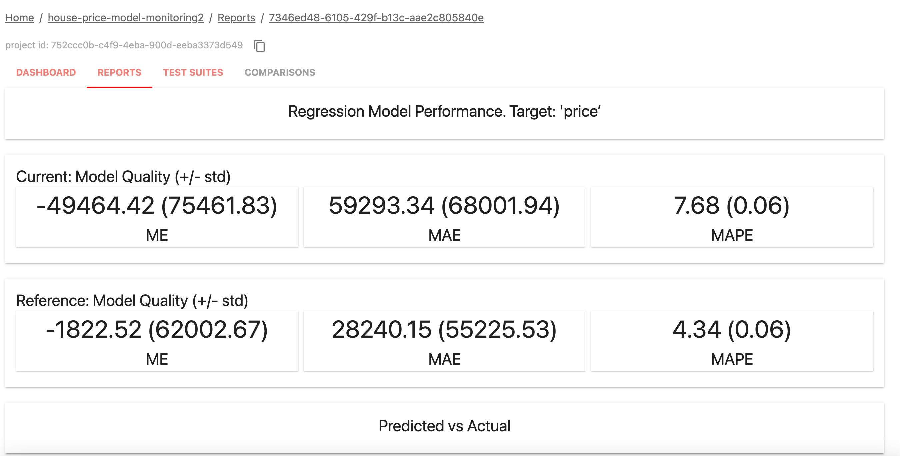

1. "Error Bias Table"+"Predicted vs Actual per Group"

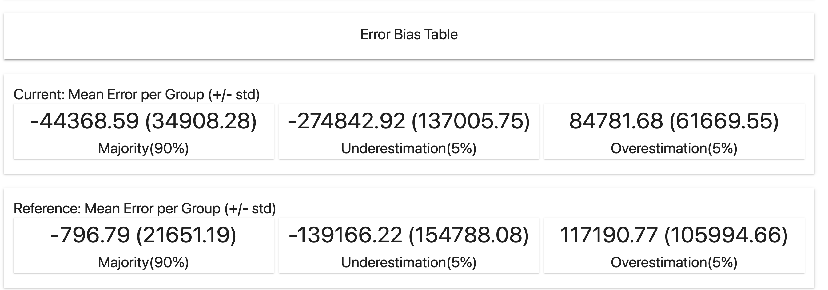

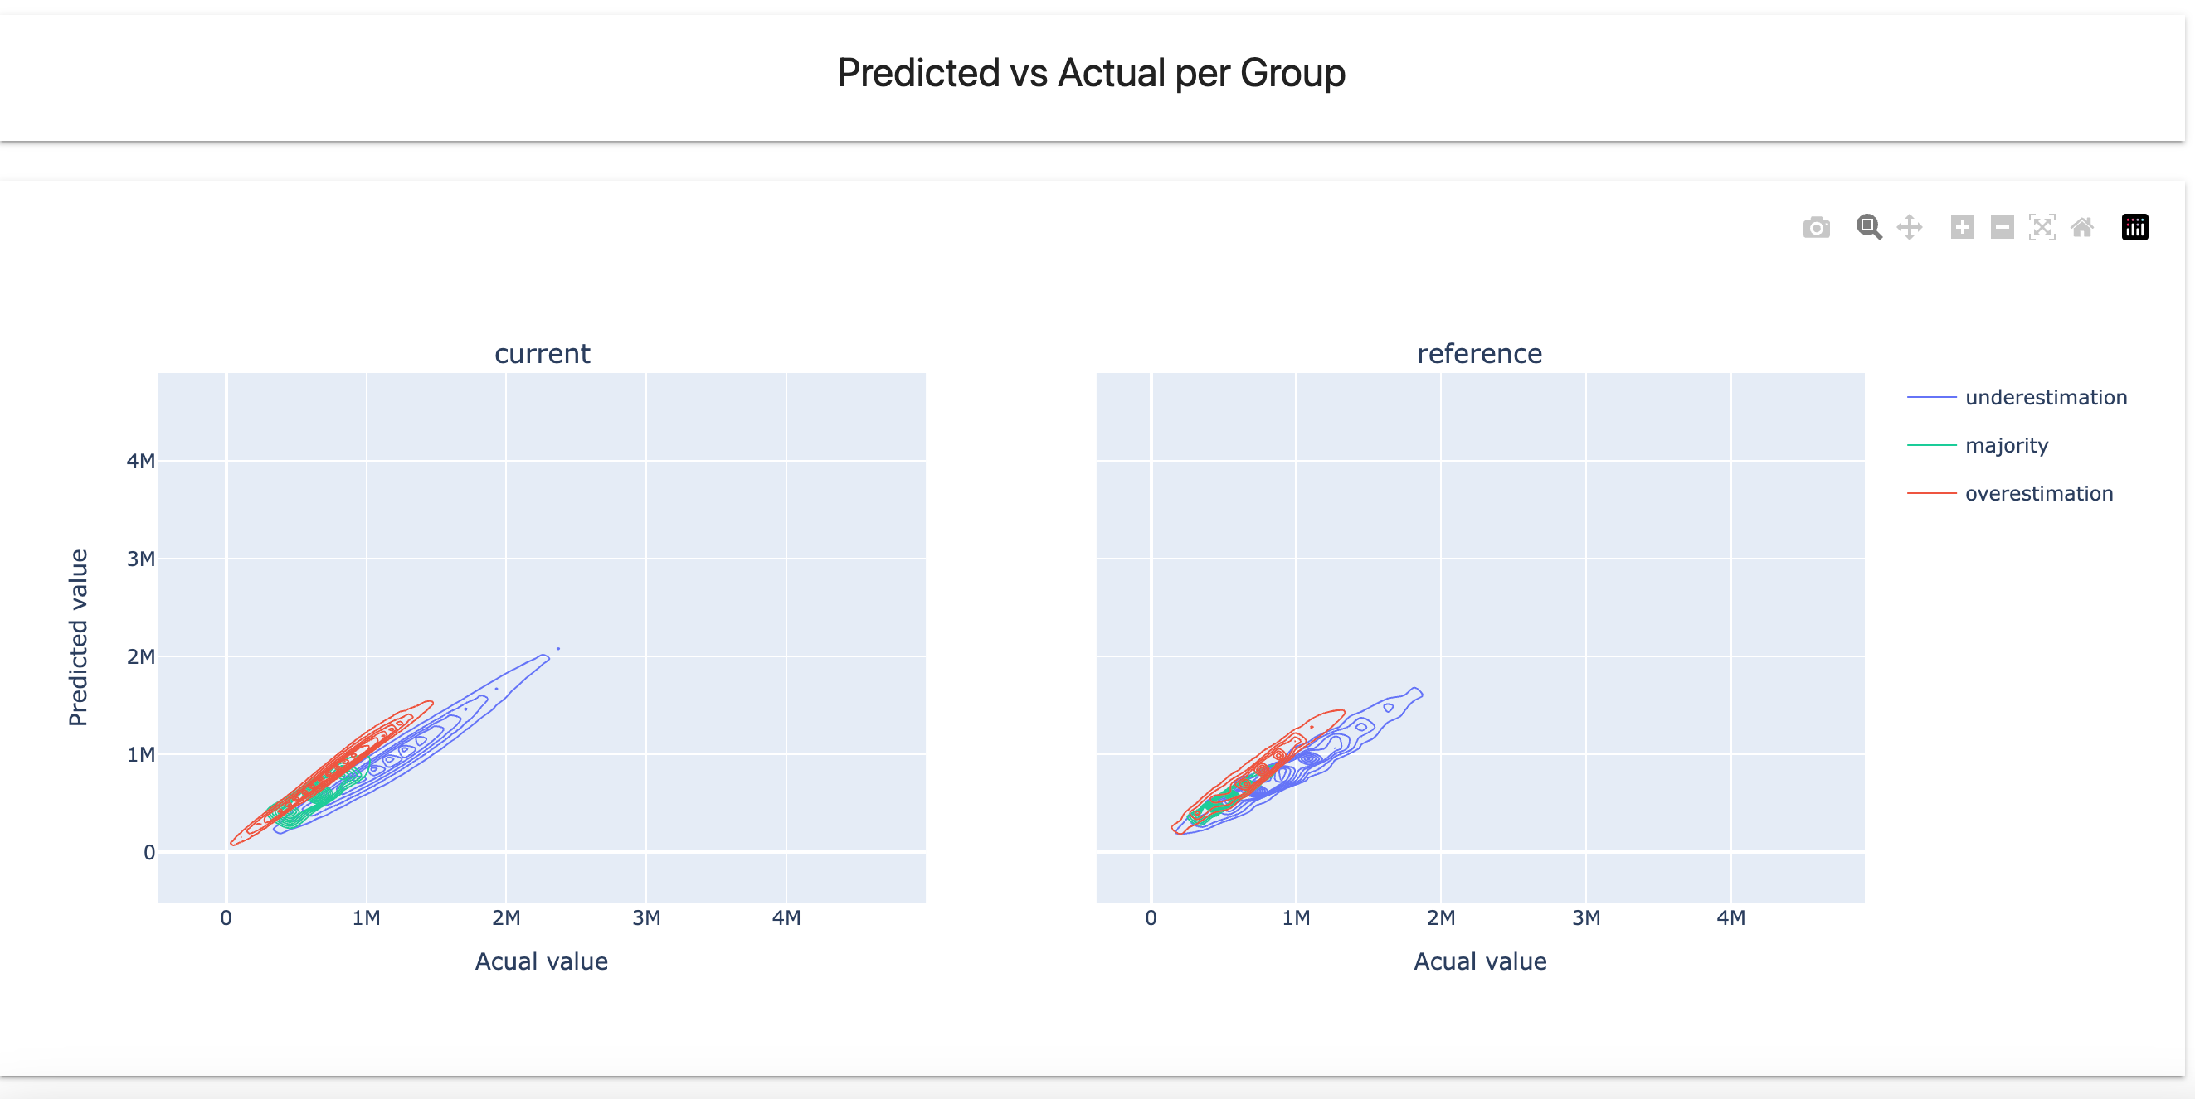

3)"Data Drift Summary"

